# User Manual for Posting Data from Frontend to Backend through Web API

## Project Description:

Using Angular designed the front-end form to get the data and add the new data to the back end. Create the web API swagger link using ASP.NET Web API applications. Storing data in to the local SQL DB.

### Front End Form URL: **http://localhost:4200/EMPBasicDetails/add**

Fetch the data from backend using GET method of web API

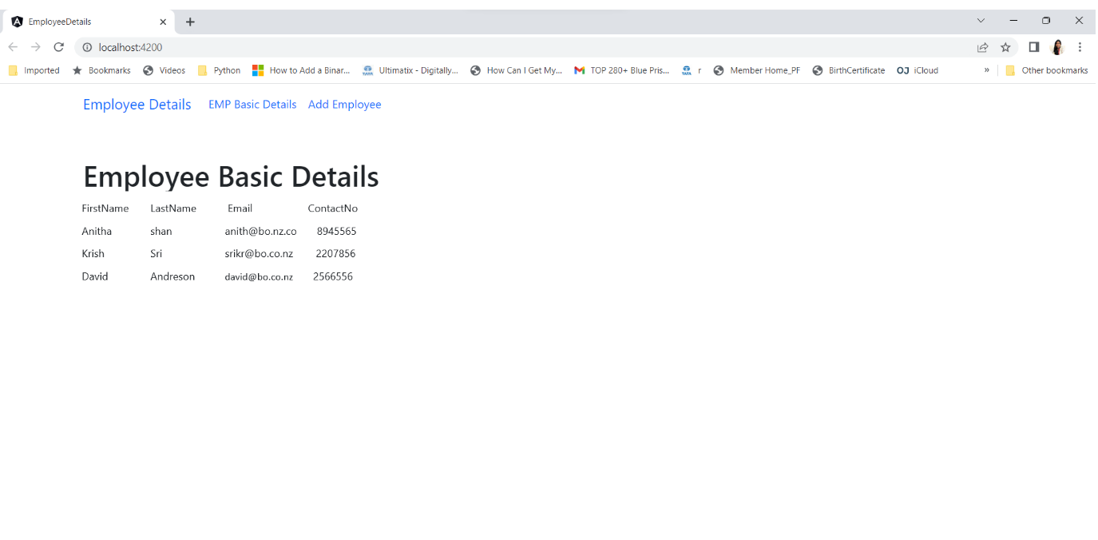

Web API URL: **https://localhost:7286/swagger/index.html**

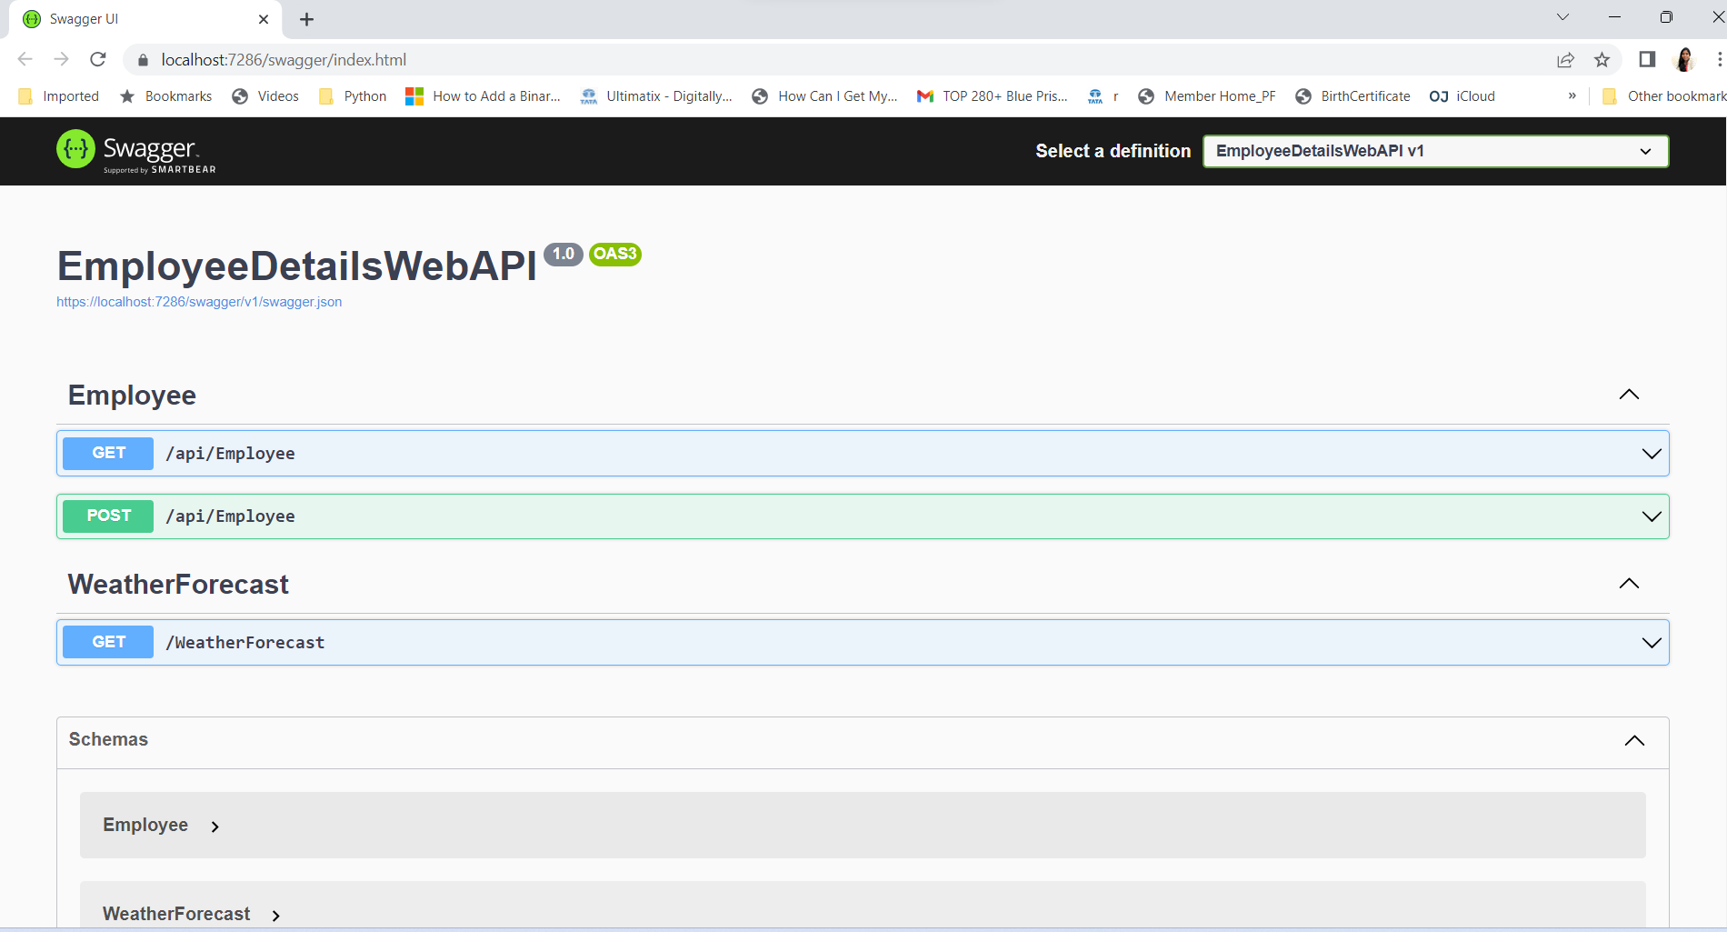

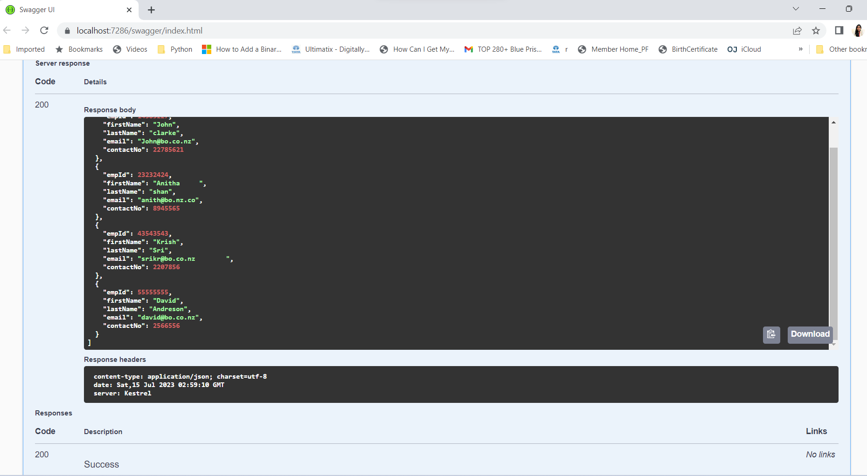

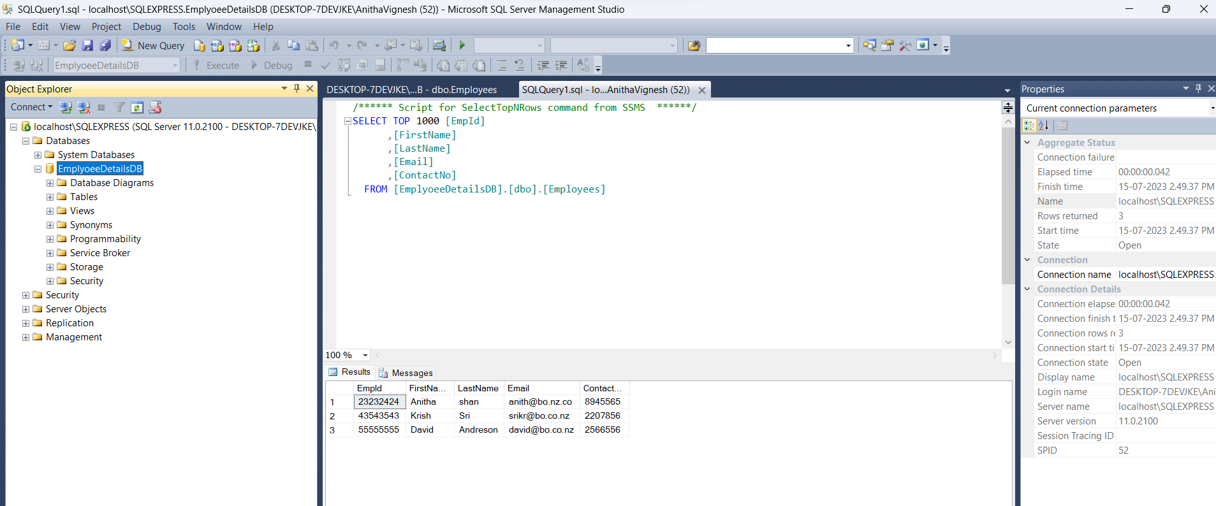

Add the user details using POST method of web API

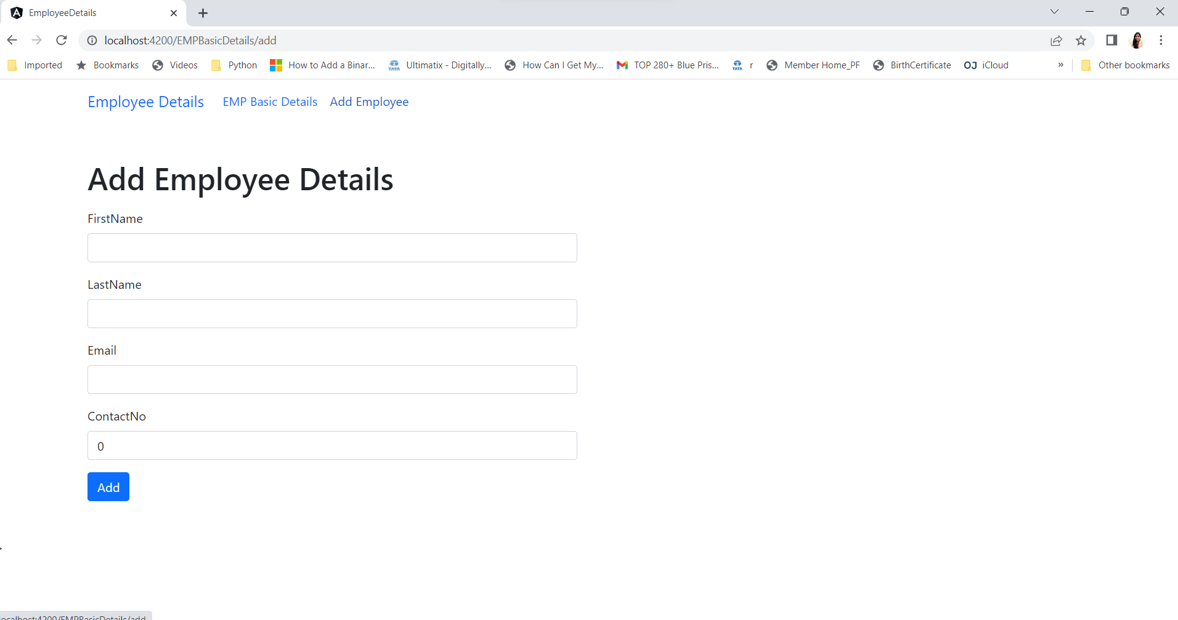

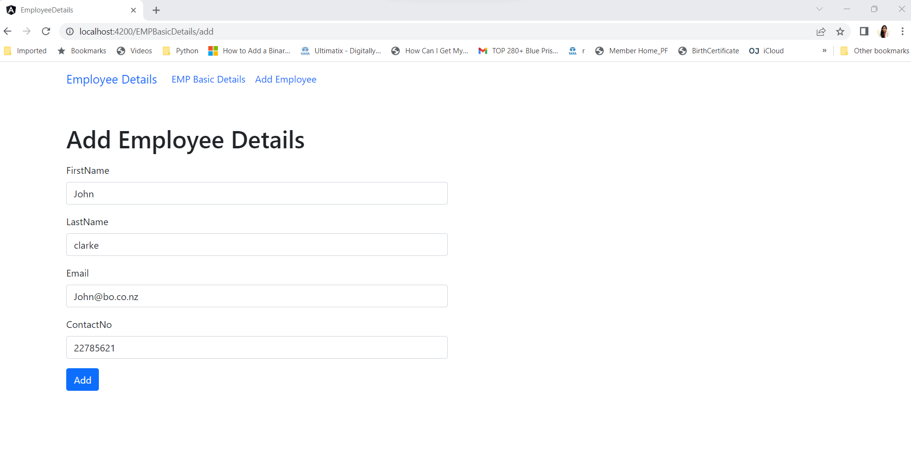

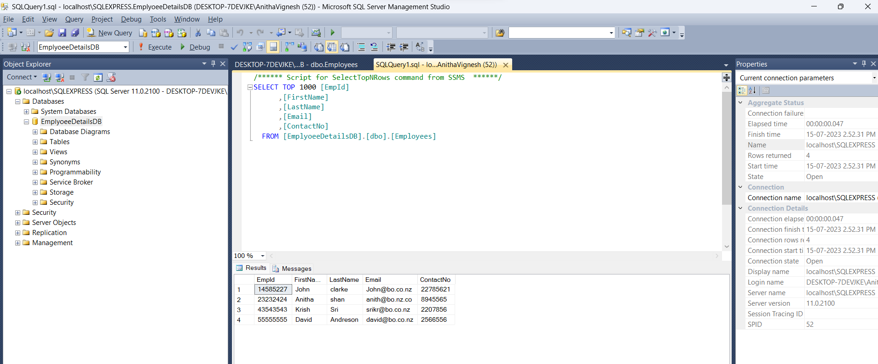

<https://localhost:7286/swagger/index.html>



